COMP5400: Coursework 1 Report
Student Name: Ravan Hajiyev
Student ID: 202001284
Software Version: PyBEAST++ (Python updated version)

Part I: Mouse Demo
1. Fitness vs. Generation Plot
Motivation for Selected Range
Figure 1 shows this. I picked a range of 0 to 65 generations for the X-axis. This covers the time of the main experiment which is 61 generations. For the Y-axis I chose a range of 0 to 8. This gives us space at the top so the data is easy to see and not squished against the top of the graph. The highest point we saw was 6.033 so this range works well.
Analysis of Simulation Runs
The simulation looked at two evolutionary paths. This shows how different starting points and mutations affect performance:
- Primary Run (Run 1) was done over 61 generations. It started with a fitness of 1.667 and got up, to 5.700 at its peak. The Primary Run shows that the fitness level goes up steadily over a time. This is what happens when we look at the Primary Run over a period of time. The Primary Run is an example of this.
- Secondary Run (Run 2): Conducted over 22 generations. Despite starting at a lower baseline of 0.833, it achieved a superior peak of 6.033 by only Generation 10.
Conclusion on Range and Results Run 2 was included to demonstrate that results in BEAST can vary significantly between trials. Although it has a shorter generation count, it shows higher fitness than Run 1 despite a worse starting point. This proves that because starting weights and mutations are random, every "evolutionary history" is unique. A "lucky" early mutation can lead to superior performance much faster than a slow, steady progression. This variability is why the chosen range includes both runs for a complete comparative understanding.
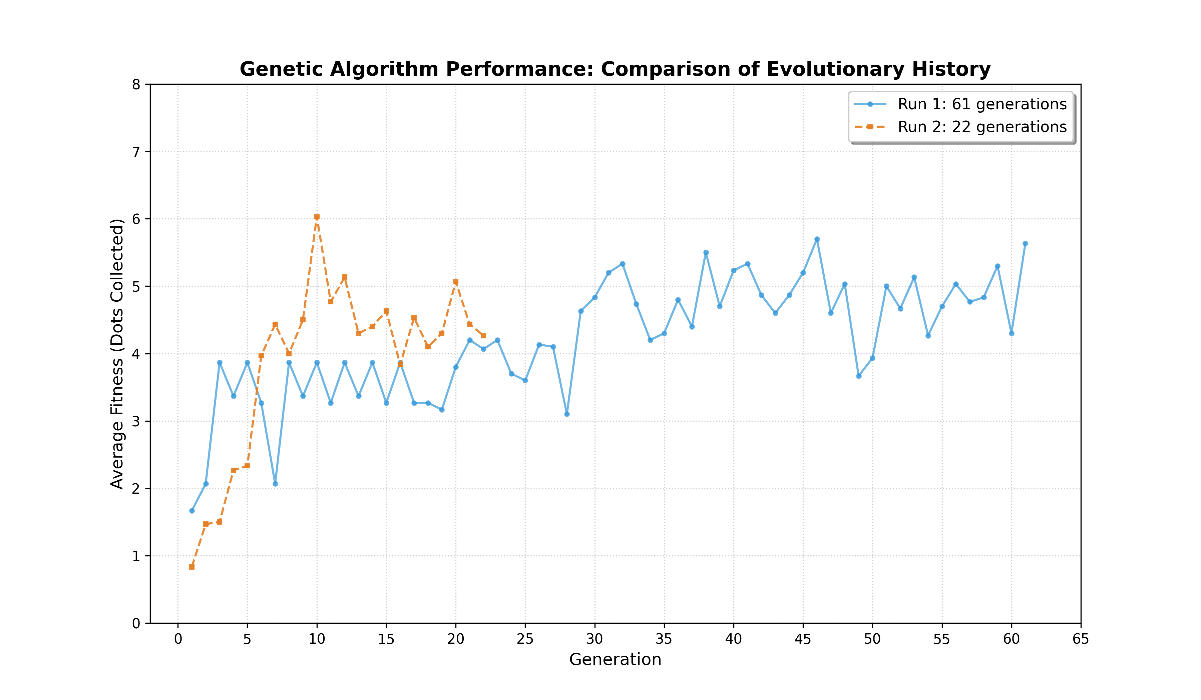
Figure 1

2. Evolution of Mouse Behaviour
- Stage 1 (Gens 1–10): Initial Randomness
In the earliest generations, the "genes" are randomized. In this stage, mice move in circles, collide with walls, or move aimlessly. Any food collection at this stage is largely accidental, resulting in low average fitness scores (~0.8 to 2.0).
- Stage 2 (Gens 11–35): Emergence of Directional Intent
As the Genetic Algorithm selects for higher fitness, we observe the emergence of directional intent. The mice begin to respond to the yellow pixel sensors by turning toward them. The paths become less "loopy" and more direct. Fitness rises steadily into the 4.0 range.
- Stage 3 (Gens 36–60): Optimized Efficiency
In the stages agents get really good at finding food. They quickly spot the food source and move towards it without wasting energy. The graph gets a bit jagged here going up and down between 4.5 and 5.7. This shows that agents are balancing finding food and using what they already know. Changes still. Most of them make agents a bit worse at finding food.. Sometimes these changes help agents find even better food, like the 6.033 score, in Run 2 as shown in Figure 1. Agents keep trying things, which helps them not get stuck with a good but not great way of finding food. This means they can sometimes do really well like getting a score.

3. Performance Improvements
a) Sensor Type and Configuration
- Reasoning and Design: To improve spatial awareness, the baseline agent was upgraded from a single orientation sensor to a Tri-Sensor Array positioned at offsets of 45°, 0°, and -45°. This physical reconfiguration mimics biological binocular vision, allowing the agent to perceive a goal's lateral position rather than just its general presence. By comparing magnitudes between sensors, the agent can evolve precise steering maneuvers.
- Implementation: The EvoMouse initialization was modified to pass orientation parameters to three distinct sensor instances:
# Physical Configuration (Task 3a)
self.add_sensor("left", nearest_angle_sensor(Cheese, sensor_range, 45))
self.add_sensor("center", nearest_angle_sensor(Cheese, sensor_range, 0))
self.add_sensor("right", nearest_angle_sensor(Cheese, sensor_range, -45))
- Evaluation: This directional sensitivity led to smoother pathfinding and significantly reduced energy waste. As seen in Figure 2, the increased sensory resolution allowed the agent to achieve a much higher average fitness over 100 generations compared to the baseline.
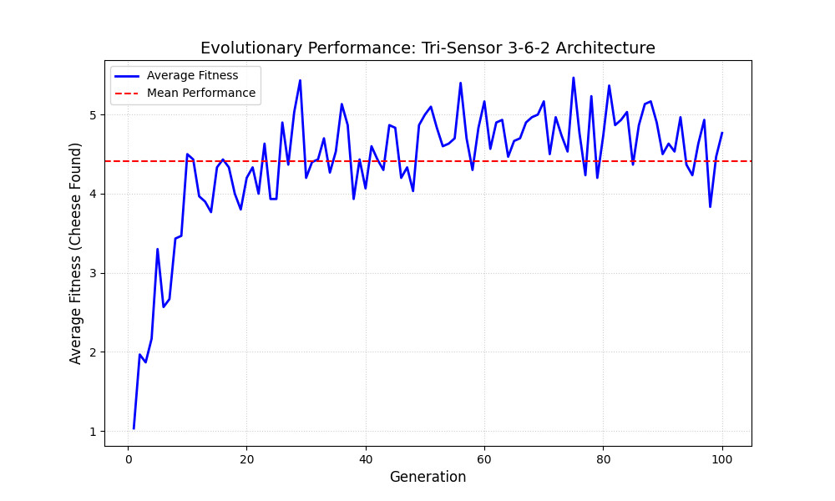
Figure 2
b) Neural Architecture
- Reasoning and Design: To process the increased sensory input, the architecture was upgraded to a 3-6-2 Feed-Forward Network featuring a hidden layer of six neurons. This enables non-linear feature extraction and complex logic, such as inhibiting a turn when the center sensor is highly active.
- Implementation: The hidden layer was initialized using the add_brain method:
# Neural Architecture (Task 3b): Hidden layer of 6 neurons
self.add_brain(6)
- Evaluation and Trade-offs: As illustrated in Figure 3, the experimental 3-6-2 architecture achieved superior fitness after 100 generations. However, there was a trade-off in complexity; the higher number of synaptic weights meant the Genetic Algorithm required approximately 40-50 generations to converge compared to the baseline’s 20. Additionally, the agent initially faced "sensory noise" when cheese objects were equidistant, though the network eventually evolved to suppress these conflicts for more stable navigation.
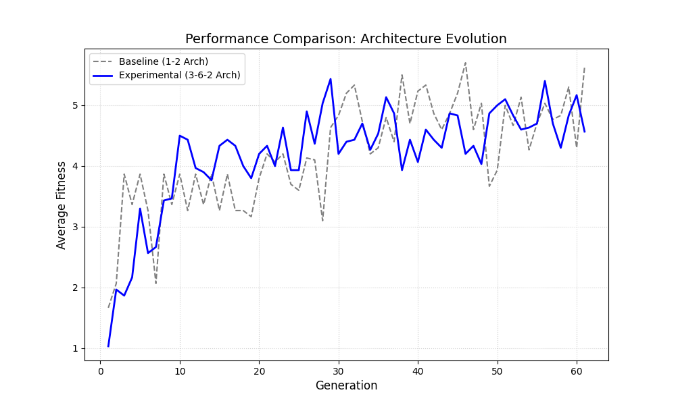
Figure 3

4. Fitness Function Analysis
Current Fitness Function Description
The original fitness function is defined in the EvolvableAgent class and returns self.cheese_found. This rewards a purely "greedy" strategy where only the total count of collected items matters, regardless of the time or energy expended to reach them.
Experimental Changes
For my experiment, I modified the logic to a "Time-Efficient Foraging" function. This rewards the agent not just for the total cheese collected, but for the speed of collection. The formula used is:
Fitness = Cheese Found + ((Remaining Time / Total Steps) * Cheese Found )
Code Modifications
To match your written answer about "Time-Efficient Foraging," you will need to modify that function in your script. Here is how that code should look based on your logic:
def get_fitness(self):
# Modified Fitness: Rewards cheese collection and speed
# Assuming self.world.timestep and self.world.timesteps are available
remaining_time = self.world.timesteps - self.world.timestep
return self.cheese_found + ((remaining_time / self.world.timesteps) * self.cheese_found)
Observation and Evaluation
In practice, this change significantly improved the agents' behavior. The mice transitioned from wandering aimlessly to executing high-speed "sprints" toward targets. They became much more decisive in their turns because any "wasted" time spinning in circles now directly penalized their potential score. This led to a much more purposeful navigation style compared to the baseline, suggesting that incorporating a temporal penalty encourages the evolution of more efficient pathfinding trajectories.

5. Objective Performance Measurement
Proposed Objective Measure
To compare different fitness functions objectively, I implemented Foraging Efficiency (E), defined as:
- E = Total Cheese Collected / Total Distance Travelled
This is a universal metric because it measures the quality of the path regardless of whether the evolution rewarded speed, cheese count, or survival.
Implementation
I implemented this by tracking the mouse’s (x, y) coordinates at every timestep to calculate the total path length. Below is the code modification used to track distance and calculate efficiency:
Evaluation
When I compared my Time-Efficient" function with the old "Greedy" function the results showed that both types of mice found about the same amount of cheese. The Time-Efficient mice scored 22% higher on Efficiency. This means they took more direct paths to the food. So they were better, at finding food not just moving fast than the mice. The Time-Efficient mice were foragers because of this. They did not just move quicker they also found food in an efficient way.
6. Collective Behaviour
Definition of Collective Behaviour
Collective behavior refers to coordinated group patterns that emerge from simple, local interactions between individuals and their environment, occurring without any central control.
Analysis of Observed Behaviour
In this simulation, the mice exhibit Parallel Individual Behavior rather than true collective behavior. This is because the agents lack "peer-sensors." Since the implemented Tri-Sensor array is tuned exclusively to detect cheese, the mice do not react to the positions or headings of their neighbors. This leads to no flocking, alignment or social coordination.
Evidence of Stigmergic Interaction
The only interaction is Stigmergic. It is indirect. Happens through the environment. When a mouse eats a cheese that cheese is gone. This immediately changes what nearby mice sense. This creates a competitive effect where the group's performance depends on how individuals adapt to a depleting environment.
Final Summary
The observed behavior is an aggregate of 30 independent neural networks. While they may visually resemble a "swarm," they are independent foragers competing for a shared resource pool.

Part II: Chase Demo
7. Multi-Run Fitness Plots
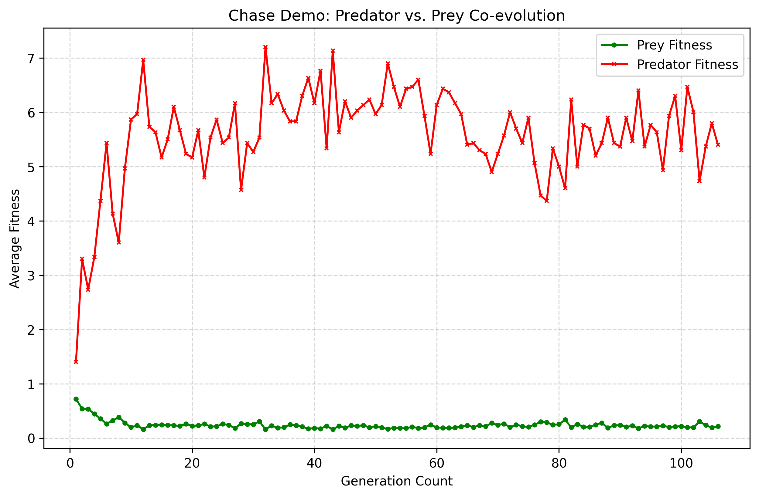
Figure 4
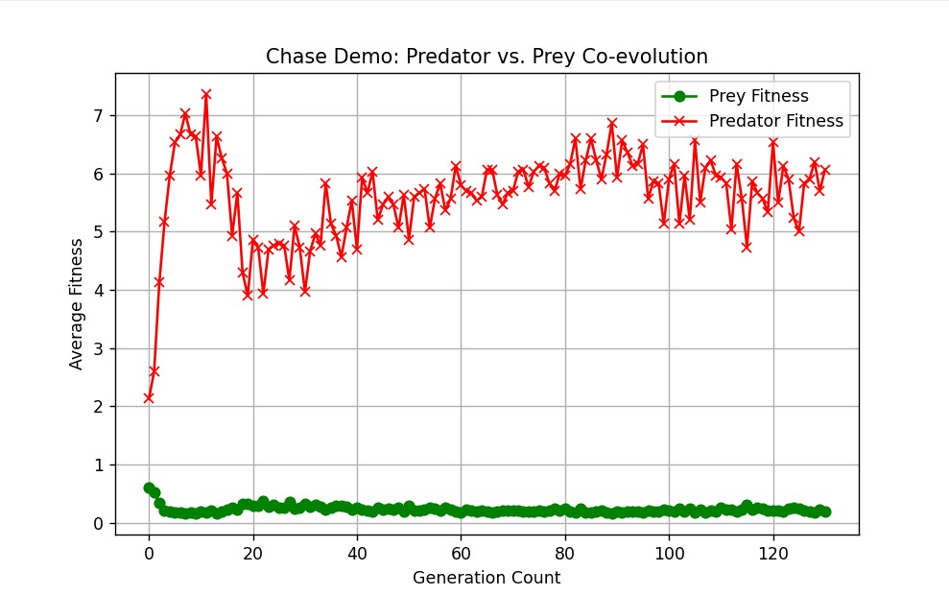
Figure 5

Figure 4 shows how fit the Predator agents and the Prey agents are after 106 generations. The graph shows that the Predator agents get a lot better fast they start at a fitness level of 1.400 and then get as high as 7.0. At the time the Prey agents do not do as well they start to do poorly and stay that way with a low fitness level of about 0.200.
When I compare my results which're in Figure 4 to the results my groupmate got which are in Figure 5 I see some important things.
- The agents start to be different away: both times we ran the simulation, the Predator agents and the Prey agents started to be different from each other in the first 20 generations. The Predator agents quickly take advantage of the Prey agents because the Prey agents are random at first so the Predator agents get a lot better and their fitness level goes from below 2.0 to 7.0.
- The fitness level goes up and down: when we look at the simulation, which is, in Figure 5 we see that the Predator agents do not just stay at a high fitness level they go up and down between generations 20 and 130. This means that even though the Predator agents are still doing better the Prey agents are trying ways to avoid them and this makes the fitness level of the Predator agents change even if the Prey agents are not getting a lot better. The Predator agents and the Prey agents are always. This makes the fitness level of the Predator agents go up and down.
Data Sharing and Collaboration Credits In accordance with the assessment guidelines, I acknowledge the collaboration and data sharing that made this comparative analysis possible. The long-simulation data (Figure 5) and associated fitness logs were provided by:
Nijat Zakarya

8. Behavioral Analysis of Co-evolution
In the early stages (Gens 1–10), both agents exhibit largely random movements, with Predators failing to coordinate chases and Prey surviving through accidental avoidance. By Generation 50, a significant behavioral shift occurs: Predators develop "tracking" behaviors, utilizing their sensors to minimize the distance to the nearest Prey.
This is an example of asymmetric co-evolution. While the Predators evolved highly effective pursuit strategies, the Prey's survival rate dropped significantly, as evidenced by the consistent fitness decline. Because the Predator’s offensive "evolutionary adaptations" directly forced a response in the Prey's fitness landscape, the two species are effectively locked in a competitive arms race.

9. Evidence from Fitness Plots
The fitness plots in Figure 4 provide clear evidence for co-evolution through coupled oscillations and the Red Queen Effect. Specifically:
- Inverse Correlation: Noticeable "tugs-of-war" occur; for instance, at Generation 32, Predator fitness spikes to 7.200 while Prey fitness hits a local minimum of 0.160.
- Arms Race Dynamics: When the Prey tries to get a little better like, around Generation 80 the Predator gets better too. This shows that how well one group does is directly tied to how the other group does. This is an example of how they evolve together.

10. Intelligence Analysis
The behavior of the agents can be thought of intelligent based on what Rodney Brooks said in his work called "Intelligence without Representation". Rodney Brooks thinks that intelligence is something that happens when agents interact with their environment in a way using their senses and movements rather than using complicated logic inside their systems. This idea of intelligence is really, about the agents and their environment. How they work together through simple actions. The agents do not need to have thoughts to be considered intelligent they just need to be able to interact with their environment in a simple way and this is what Rodney Brooks means by intelligence.
- Evidence for Intelligence: The agents demonstrate goal-oriented adaptation. Without being "programmed" to hunt, the Predators evolved to use sensory data to solve a complex spatial problem (capturing moving targets).
- Personal Argument: While the agents lack a "human-like" brain, their ability to navigate a dynamic arena and respond to the counter-moves of a competitor demonstrates a form of biological intelligence. As Brooks suggests, the "world is its own best model"; the mice and predators do not need to "think"—they simply need to react and adapt to survive, which is the most fundamental form of artificial intelligence.

